Pidilite Industries Showcases Comprehensive Construction & Interior Solutions at ACETECH Bengaluru 2025
~ Showcases solutions, expert brands, end-to-end services, and sustainable innovation ~
~ Introduces Pidilite Professional Solutions (PPS), a dedicated vertical designed to serve the construction fraternity~
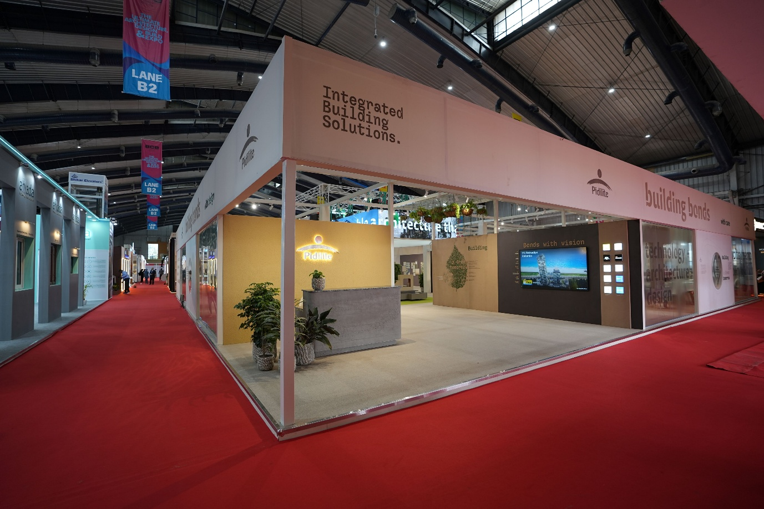
Bengaluru, 14th October 2025 – Pidilite Industries Limited, India’s leading manufacturer of adhesives, sealants, and construction chemicals, unveiled its full-spectrum offering for the construction and interior ecosystem at ACETECH Bengaluru 2025.

At the event, Pidilite also introduced Pidilite Professional Solutions (PPS), a dedicated vertical designed to serve the entire construction fraternity of architects, structural consultants, developers, contractors, and interior specialists, with integrated solutions that go beyond products to deliver end-to-end project excellence.

Commenting on the launch, Kavinder Singh, Joint Managing Director, Pidilite Industries Ltd., said, "At Pidilite, we believe in enabling the construction fraternity to build boldly and sustainably. With Pidilite Professional Solutions (PPS), we’re not just offering products; we’re delivering a complete ecosystem of technical services and solutions and trained applicators to meet the needs of various project segments: Hotels, Hospitals, Educational institutions, Residential , Commercial, Datacentres, Industries and Infrastructure.We are committed to bringing World class & pioneering solutions at every stage of the project journey."

PPS is powered by a portfolio of expert brands across categories - Dr. Fixit, Roff, Starlike, Tenax, Unofin, Walace, ICA, Fevicol, Araldite, Dr. Cipy, and Feviseal - each trusted for performance, innovation, and reliability. These brands are backed by Pidilite’s expertise built on 65 years of trust and innovation excellence.

What sets PPS apart is its “Sketch to Site” approach, enabling bold design execution with comprehensive support across every stage of the project lifecycle. PPS offers customized detailing with technical specifications, bill-of-quantities, and tender-ready estimates, freeing architects to focus on design. It also provides site audits and project tracking, along with a nationwide network of trained partner applicators. For large and complex projects, PPS offers access to Nina Percept, India’s largest expert waterproofing contracting company. Post-handover support ensures sustained performance and long-term value.

A key highlight at the exhibition was Pidilite’s Building Envelope Solutions, which reduce energy costs by up to 50%, contributing to a greener, more sustainable India. These solutions are aligned with ECBC norms and support long-term energy efficiency and operational savings.

Pidilite’s offerings are tailored for diverse segments including Residential, Commercial, Healthcare, Hospitality, Educational Institutions, Industrial, Infrastructure, Government, and Individual Home Builders (IHB), ensuring every project benefits from resilient, high-performance solutions.
Through its presence at ACETECH Bengaluru 2025, Pidilite Industries reinforced its commitment to advancing construction excellence, strengthening B2B partnerships, and leading the way in sustainable, high-quality building solutions across India and beyond.

***

About Pidilite:
Pidilite Industries Limited is a leading manufacturer of adhesives and sealants, construction chemicals, craftsmen products, DIY (Do-It-Yourself) products and polymer emulsions in India. Our products range also includes paint chemicals, automotive chemicals, art materials and stationery, fabric care, maintenance chemicals, industrial adhesives, industrial resins and organic pigments & preparations. Most of the products have been developed through strong in-house R&D. Our brand name Fevicol has become synonymous with adhesives to millions in India and is ranked amongst the most trusted brands in the country. Some of our other major brands are M-Seal, Fevikwik, Fevistik, Roff, Dr. Fixit, Araldite and Fevicryl.

For any further queries, please contact:
Hiral Jani Vasani | Hiral.Vasani@pidilite.com
Head, Corporate Communications

